DISSERTATION NOTES

D1 – Project Proposal & Research Document
https://canvas.hw.ac.uk/courses/32091/pages/6-dot-3-project-proposal-and-research-document-d1?module_item_id=2297697

- A project proposal’s sections.
- Research on a topic or theme.
- Preparation, design and feasibility work.
- Planning and management of the project.
- Development of a system, methodology or probe.
- Implementation of user studies, validation or performance tests.
- Evaluation of the system or results.
- Discussion of results, creation of insights or conclusions, and communication of them.

Personal Notes:
Max of 3 direct quotes throughout the lit review. Everything else is paraphrasing.
IDEA: Do a comparison of results for datasets before and after normalizing. Like:
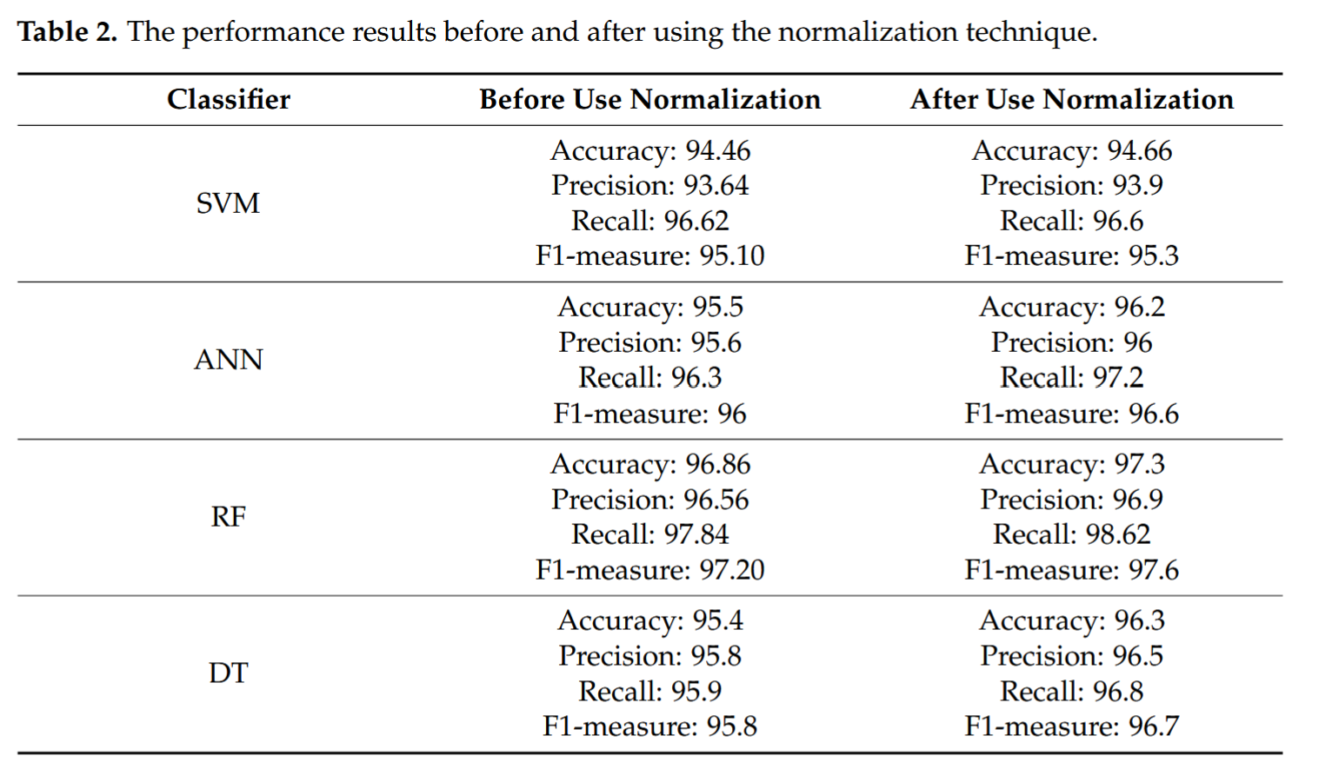
Possible Options:

Dataset:
https://archive.ics.uci.edu/dataset/327/phishing+websites
https://data.mendeley.com/datasets/72ptz43s9v/1

Datasets Provided by Supervisor are the ones we’ll be using. They’re in the datasets folder. The full and small csvs are the Mendeley 2020 datasets.

No. | Paper Title | Publication (Where & When) | Dataset | Proposed Method/Algorithm | Accuracy | Used in Lit Review?
1 | Sufficiency of Ensemble Machine Learning  Methods for Phishing Websites Detection | IEEE, 24th November 2022 | UCI_2015, Mendeley_2018, Mendeley_2020 | Random Forest | 96.94% | Yes
2 | RSTHFS: A Rough Set Theory-Based Hybrid  Feature Selection Method for Phishing  Website Classification | IEEE, 25th April 2025 | UCI_2015, Mendeley_2018, Mendeley_2020 | RSTHFS + CatBoost | 96.48% | Yes
3 | Multilayer Stacked Ensemble Learning Model to  Detect Phishing Websites | IEEE, 3rd August 2022 | UCI_2015, Mendeley_2018, Mendeley_2020 | Multi-Layer Stacked Ensemble Learning Model (1. XGB,LR,RF,MLP,KNN 2. XGB,RF,MLP 3. XGB) | 98.43%  (training time metric not specified) | Yes
4 | A Deep Learning-Based Framework for  Phishing Website Detection | IEEE, 6th January 2022 | https://www.kaggle.com/  siddharthkumar25/malicious-and-benign-urls,  https://www.  phishtank.com/phish_archive.php | RNN-GRU | 99.18% | Yes
5 | A Deep Learning-Based Phishing Detection System Using CNN,  LSTM, and LSTM-CNN | MDPI, 3rd January 2023 | ISCX-URL2016 | CNN | 99.2% | Yes
6 | A novel approach for phishing URLs detection using lexical based machine  learning in a real-time environment | Elsevier, 22nd April 2021 | ISCX-URL2016 | RF | 99.7% | Yes
7 | Detecting Phishing Domains Using Machine Learning | MDPI, 7th April 2023 | UCI_2015 | RF | 97.3% | Yes
8 | Detection of Phishing URLs Using Machine Learning  Techniques | 2013 International Conference on Control Communication and Computing (ICCC) | Phishtank URLs, alexa.org | J48 Decision Tree | 93.2% | Yes
9 | A Novel Machine Learning Approach to Detect  Phishing Websites | 2018 5th International Conference on Signal Processing and Integrated Networks (SPIN) | 100 URLs from PhishTank | RF | 98.40% | Yes
10 | Detection and Prevention of Phishing Websites  using Machine Learning Approach | 2018 Fourth International Conference on Computing Communication Control and Automation (ICCUBEA) | Unclear, but they are URLs | RF | 96.58%
11 | Analysis of the Performance Impact of Fine-Tuned Machine  Learning Model for Phishing URL Detection | MDPI, 30th March 2023 | UCI_2015,  Mendeley_2018 | Gradient Boosting after fine tuning hyper-parameters | 98.27% | Yes
12 | Comparative evaluation of machine  learning algorithms for phishing site  detection | PeerJ, 24th June 2024 | UCI_2015,  Mendeley_2018 | CNN, among others | 99% | Yes
13 | Phishing Website Detection With  Semantic Features Based on  Machine Learning Classifiers:  A Comparative Study | Open Access article distributed under the terms of the Creative Commons Attribution License | Mendeley_2018 | RF | 99.06% | Yes
14 | An Optimized Stacking Ensemble Model for Phishing  Websites Detection | MDPI, 28th May 2021 | UCI_2015, Mendeley_2018, Mendeley_2020 | RF, LightGBM, RF  GA(genetic algorithm)-based ensemble:  GA-GradientBoost, GA-XGBoost, GA-XGBoost | 97.02%, 98.65%, 97.15%  97.13%, 98.57%, 97.35% | Yes

D1:

Sections: Front matter, main body, back matter
Title page
Declaration
Abstract
Table of contents
Introduction (starts at page number 1) -> summarising the context and motivation of the project, stating the aim and objectives of the project, identifying the problems to be solved to achieve the objectives, and sketching the organisation of the dissertation.
Background research -> discussing related work found in the technical literature and its relevance to your project.
Methodology / Work plan -> describe in detail the necessary methods, requirements or research questions that will be employed or be needed to complete the project. You should link these back to your project aim and objectives. If needed include suitable research questions, use cases, research methods that are going to be employed, stakeholder research, requirements, and / or Moscow analysis.
Methods
Requirements
Research questions
Use cases, research methods, stakeholder research, Moscow analysis
Feasibility: include a summary of preliminary work carried out in preparation for your project to validate the feasibility of your project. This includes design, evaluation strategy and preliminary work (e.g. focus groups, stakeholder information, tests of software, evaluation of tools, possible datasets or algorithms, and early prototypes) – this section will complement the information in your second deliverable.
Conclusions – summary of whole document
Max Length of Main Body is 14 pages
References
Project Management
- Gantt chart (or plan) of activities that were carried out in the first semester, and future plan of activities to be carried out on the second semester.
- Analysis of risks with appropriate mitigation plans for the project.
- PLES: A well-researched consideration of any Professional, Legal, Ethical, and Social Issues pertinent to the project. (e.g. codes of conduct (BCS), codes of practice, standards, computer law, ethical decision making, intellectual property, social aspects, copyright, data protection, and so on).
- Possible Acknowledgment
GenAI Summary: this is a required section summarising the use of GenAI in your project and deliverables.
Appendices: include supplementary materials as appropriate, if in doubt, please consult with your supervisor. Useful appendices include additional screenshots, charts and information that does not fit in the main body of your document, it is discretionary, but complements the document.

D3:
Dissertation (D3)
This is your main deliverable, and it will detail your project development, evaluation, discussion and conclusions. This document will extend the previous Project Proposal deliverable, and new sections will only be marked (the previous sections will not contribute again to your mark, but you are welcome to update or modify the previous content if needed – e.g. the project changed slightly).

Sections: Front matter, d1, main body, back matter

Title page
Declaration
Abstract
Table of contents: table including the all the sections. Make sure the start of the Main body section (introduction) starts at page number 1.
Introduction (starts at page number 1) -> summarising the context and motivation of the project, stating the aim and objectives of the project, identifying the problems to be solved to achieve the objectives, and sketching the organisation of the dissertation.
Background research -> discussing related work found in the technical literature and its relevance to your project.
Methodology / Work plan -> describe in detail the necessary methods, requirements or research questions that will be employed or be needed to complete the project. You should link these back to your project aim and objectives. If needed include suitable research questions, use cases, research methods that are going to be employed, stakeholder research, requirements, and / or Moscow analysis.
Methods
Requirements
Research questions
Use cases, research methods, stakeholder research, Moscow analysis
Feasibility: include a summary of preliminary work carried out in preparation for your project to validate the feasibility of your project. This includes design, evaluation strategy and preliminary work (e.g. focus groups, stakeholder information, tests of software, evaluation of tools, possible datasets or algorithms, and early prototypes) – this section will complement the information in your second deliverable.
Implementation and Contributions: describe here in detail your implementation or work and your contributions.
Evaluation: detail here your testing, performance analysis, studies, results, validation and any other detail related to the evaluation of your project.
Discussion and Conclusions: discuss insights, limitations, achievements, future work, and conclude your project dissertation.
Max Length of Main Body is 20 pages
References
Project Management
- Gantt chart (or plan) of activities that were carried out in the first semester, and future plan of activities to be carried out on the second semester.
- Analysis of risks with appropriate mitigation plans for the project.
- PLES: A well-researched consideration of any Professional, Legal, Ethical, and Social Issues pertinent to the project. (e.g. codes of conduct (BCS), codes of practice, standards, computer law, ethical decision making, intellectual property, social aspects, copyright, data protection, and so on).
- Possible Acknowledgment
GenAI Summary: this is a required section summarising the use of GenAI in your project and deliverables.
Appendices: include supplementary materials as appropriate, if in doubt, please consult with your supervisor. Useful appendices include additional screenshots, charts and information that does not fit in the main body of your document, it is discretionary, but complements the document.

There is no recipe for a “perfect” dissertation; the above is a set of good practice guidelines to structure your document. You are strongly encouraged to ask your supervisor for examples of good-quality dissertations from previous years or to browse the past projects available in Canvas (please note that the format and length can change from year to year). Use the marking rubrics to guide you on which areas you will be assessed.
Please note that some of the feasibility sections or work might be included in the implementation part to make the narrative and structure in your final dissertation flow better. If you do change parts from your D1 body, then please summarise these in the section before the appendices.
You will be required to use the LaTeX or Word templates provided. Do not modify the format of these templates. Structure provided on top should be followed, and slight rearrangements of sections are possible, but please consult your supervisor first. The maximum page limit for the Main Body is 20 pages. The Front and Back Matter sections can be of any length. D1 Body section should not exceed the previous limit, and please note that you will not be awarded more marks for this section. The final document should be a PDF document.

Final document is a PDF.

PLAN:
Okay so 20 extra pages to work with (thanks dickhailescu).
Just keep writing and worry about reducing size later.

ADVICE:
REMOVE RSTFPS FROM D1
MOVE CONVO LAYERS AND CNN STUFF INTO CNN SUBHEADING
MOVE RETURN SEQUENCES, DUAL POOLING AND OTHER GRU STUFF INTO BIGRU SUBHEADING
PRE PROCESSING IS ONE PARAGRAPH
MOVE LR SCHEDULE, ADAM OPTIMIZER AND EARLY STOPPING IN EXPERIMENTATION ALONG WITH HYPER PARAM TUNING
TOTAL CONCLUSIONS SHOULD BE ONE PAGE

Methodology (4-5 Pages)
- Pre Processing Pipeline (MAX 1 PAGE)
  - Input features, each dataset
  - normalization,
  - NaN replacement with median
- FRAMEWORK
  - Small para talking about the hybrid framework
  - CNN
  - BiGRU
  - Fusion Layer
    - Overview (Brief description of: Input (URLs / emails / webpages — whatever your dataset is), Processing pipeline, Output (binary or multi-class classification) [SAME AS D1 OVERVIEW]
    - Processing
      - GAUSSIAN NOISE???????
      - 1D convolutional layer (n_filters, kernel size, activation function, padding, kernel regularizer)
      - Batch normalization
      - 1D Max pooling layer
      - Bidirectional GRU layer (n_gru_units, return sequences, dropout)
      - Attention
      - Dual Pooling layer (avg pool, max pool)
      - Dense layers (n_dense_units, activation function, kernel regularizer, batch normalization, dropout)
      - Output Layer (binary cross entropy, sigmoid)

Experimentation (3 PAGES)
- Implementation Setup
  - Hardware used for training (user pc and lab pc)
  - Software used
  - k-Fold CV, splitting,
  - 30 epochs, batch sizes
  - LR Schedule, adam optimizer, early stopping
  - Hyperparameter tuning using optuna (ADD THIS TO SOFTWARE REQUIREMENTS?, not needed to replicate?)
  - Traditional ML models
- Result Analysis
  - Ablation Study
  - Confusion matrix
  - Comparison includes the empirical metrics
  - Comparison between datasets
  - Comparison between proposed framework and traditional models and individual CNN and BiGRU
- Comparison with previous studies

Conclusions (2 PAGES, 1 PAGE FROM D1, 1 PAGE EXTRA)
- Summary
- Main Limitations
- Future Work

